 | RIVER VALLEY HIGH SCHOOL  YEAR 6 PRELIMINARY EXAMINATION

CANDIDATE NAME
CLASS | 6
CENTRE NUMBER | S |  |  |  |  |  | INDEX NUMBER

H2 CHEMISTRY |  |  | 9647/02
Paper 2 Structured Questions |  |  | 21 September 2010  2 hours
Candidates answer on the Question Paper.
Additional Materials: | Data Booklet
READ THESE INSTRUCTIONS FIRST

Write your name, class, Centre number and index number on all the work you hand in.
Write in dark blue or black pen on both sides of the paper.
You may use a soft pencil for any diagrams, graphs or rough working.
Do not use staples, paper clips, highlighters, glue or correction fluid.
Answer all questions.
A Data Booklet is provided. Do not write anything on it.
The number of marks is given in brackets [ ] at the end of each question or part question.
At the end of the examination, fasten all your work securely together.

For Examiner’s Use
1
2
3
4
5
6
Total
____________________________________________________________________________
This document consists of 18 printed pages.
Answer all questions in the space provided.

1 | The Kolbe reaction is an organic reaction named after Adolph Kolbe. It is formally a decarboxylative dimerisation and proceeds by a free radical reaction mechanism.  When the salt of a monocarboxylic acid, RCOOH, is electrolysed, an alkane (R−R) is produced via the following steps.  Step 1 : RCOO⁻ → R + CO₂ + e⁻  Step 2 : 2R → R−R  Electrolysis of a mixture of salts of two mono-carboxylic acids A (RCOOH) and B (R’COOH) produces three straight-chain alkanes C, D and E, which can be separated by fractional distillation.
 | (a) | A solution containing 0.400 g of A required 19.60 cm³ of 0.100 mol dm⁻³ barium hydroxide for complete neutralisation.  Calculate the relative molecular mass of A.
 |  |  | [2]
 | (b) | A gaseous sample of 0.300 g of C occupied a volume of 92.0 cm³ at 50 °C and 1 atm.  Calculate the relative molecular mass of C.
 |  |  | [2]

 | (c) | A 0.127 dm³ sample of D, measured at s.t.p., was burned in an excess of oxygen to produce 0.99 g of carbon dioxide.  Deduce the molecular formula of D.
 |  |  |  |  | [2]
 | (d) | Using your results from (a)–(c), suggest the structures of A to E.
 |  | A: | …………………………………………………
 |  | B: | …………………………………………………
 |  | C: | …………………………………………………
 |  | D: | …………………………………………………
 |  | E: | ………………………………………………… |  | [3]
 | (e) | When acid B is in the liquid state, its relative molecular mass is found to be almost twice that in the aqueous state.  With the aid of a diagram, explain this observation.
 |  | Diagram:
 |  | Explanation: |  | ……………………………….…………………………………….
 |  | ………………………………………………………………………………...……….
 |  | ………………………………………………………………………………...……….
 |  | ………………………………………………………………………………...……….
 |  | ………………………………………………………………………………...………. |  |  | [3]
 | (f) | The pK_{a} values for three monocarboxylic acids are given below.  Explain the differences in the pK_{a} values.
  acid | pK_{a}
  CH₃COOH | 4.73
  CCl₃COOH | 0.63
  C₆H₅COOH | 4.20
 |  | ………………………………………………………………………………...……….
 |  | ………………………………………………………………………………...……….
 |  | ………………………………………………………………………………...……….
 |  | ………………………………………………………………………………...……….
 |  | ………………………………………………………………………………...……….
 |  | ………………………………………………………………………………...……….
 |  | ………………………………………………………………………………...……….
 |  | ………………………………………………………………………………...……….
 |  | ………………………………………………………………………………...………. |  |  | [3]
 |  | [Total: 15]

2 | Copper has been in use for more than 10,000 years and with present global reserves projected to be approximately 10¹⁴ tonnes, copper is estimated to last 5 million years at our current rate of extraction.  However, not all these copper sources can be mined in a commercially viable manner by today’s technology; a large part of the world’s copper supply comes from recycling plants. High purity copper scrap is directly melted in a furnace, but lower purity copper scrap is first purified by electrolysis.
 | (a) | (i) | Using aqueous copper(II) sulfate as the electrolyte, draw a labelled diagram to show how an impure copper scrap can be purified by electrolysis.
 |  | (ii) | With the aid of an ion-electron equation, explain why the concentration of the electrolyte remains constant throughout the purification process.  You may assume that there is no change in the volume of the electrolyte during the process.
 |  |  | ………………………………………………….………………………………
 |  |  | ………………………………………………….………………………………
 |  |  | ………………………………………………….………………………………
 |  |  | ………………………………………………….………………………………
 |  |  |  | [4]

 | (b) | When 1.00 kg of impure copper scrap was electrolysed, 800 g of pure copper was collected at the cathode.  Given that the electrolysis current remained constant at 10.0 A, calculate the time (in days) required for this extraction.
 |  |  |  | [2]
 | (c) | The impure copper scrap contains many different metals alloyed with it, one of which is iron.  Explain, with the aid of the Data Booklet, why iron is not deposited together with copper on the cathode.
 |  | …………………………………...…………………………………………………….
 |  | …………………………………...…………………………………………………….
 |  | ……………………………………...…………………………………………………. |  | [2]
 | (d) | One other metal can be found in the impure copper scrap. The following reactions were carried out to determine the identity of this metal.
Electrolyte from purification vessel
add excess NH₃(aq) then filter

Residue
Filtrate
add excess NaOH(aq)

Solution X
Fe(OH)₂(s)

 |  | (i) | Suggest the two possible metal cations from the list below which could be present in solution X.  List of metal cations: Al³⁺, Ba²⁺, Ca²⁺, Pb²⁺, Mg²⁺, Mn²⁺, Zn²⁺
 |  |  | ……………………………………………………………………………….…
 |  | (ii) | Describe a simple distinguishing test which can be carried out to confirm the identity of the metal cation in solution X.
 |  |  | ………………………………………………………………………….………
 |  |  | ………………………………………………………………………………….
 |  |  |  | [3]
 | (e) | The pure copper obtained from the electrolytic cell will slowly oxidise to form copper(II) oxide when exposed to air.  Using the following data, and relevant data from the Data Booklet, construct an energy cycle to calculate the enthalpy change of formation of copper(II) oxide.  1st electron affinity of oxygen = −142 kJ mol⁻¹  2nd electron affinity of oxygen = +844 kJ mol⁻¹  enthalpy change of atomisation of copper = +305 kJ mol⁻¹  lattice energy of copper(II) oxide = −155 kJ mol⁻¹
 |  |  |  | [3]
 |  | [Total: 14]

3 | Group II nitrates decompose on heating. The decomposition temperatures for two nitrates are shown below.
  compound | decomposition temperature /°C
  magnesium nitrate | 330
  barium nitrate | 590
 | (a) | Write an equation, including state symbols, for the decomposition of barium nitrate.
 |  | ………………………………………………………………………………………… | [1]
 | (b) | Explain the difference in the decomposition temperatures for magnesium nitrate and barium nitrate.
 |  | …………………………………………………………………………………………
 |  | …………………………………………………………………………………………
 |  | …………………………………………………………………………………………
 |  | …………………………………………………………………………………………
 |  | …………………………………………………………………………………………
 |  | ………………………………………………………………………………………… | [2]
 | (c) | Soluble barium compounds are highly toxic. However, most barium salts with polyvalent anions are very insoluble. Barium sulfate, for instance, is used as an X-ray contrast medium for taking X-rays of the stomach. Before an X-ray examination is carried out, patients with digestive tract problems are given a suspension of barium sulfate to drink.  In the Celobar Incident, the manufacturer of Celobar attempted to produce barium sulfate from the cheaper barium carbonate resulting in some unreacted barium carbonate being present in the product. Nine people died from barium poisoning after being administered Celobar.  Suggest how they might have been poisoned.
 |  | …………………………………………………………………………………………
 |  | ………………………………………………………………………………………… | [1]
 |  | [Total: 4]

4 | (a) | Ammonia is an important compound used in the production of nitrogenous fertilisers and ammunition. The Haber process is the industrial method whereby nitrogen gas and hydrogen gas are reacted under suitable conditions to form ammonia gas.
 |  | (i) | Write an equation for the Haber process.
 |  |  | ……………………………………………………………..............................
 |  | (ii) | Hence, write an expression for the equilibrium constant, K_{c} for the reaction.
 |  |  | ……………………………………………………………..............................
 |  | (iii) | Calculate the value of K_{c} given the following equilibrium composition in a 2 dm³ reaction vessel at 1000 K.
  substance | amount at equilibrium /mol
  nitrogen | 14.0
  hydrogen | 18.0
  ammonia | 1.6
 |  | (iv) | Explain why a catalyst is required in the Haber process and suggest the identity of a suitable catalyst for the reaction.
 |  |  | ……………………………………………………………………….…………
 |  |  | ……………………………………………………………………….…………
 |  |  | ……………………………………………………………………….…………
 |  |  | ……………………………………………………………………….…………

 |  | (v) | The forward reaction in the Haber process is exothermic and the entropy change, ΔS, is negative.  Briefly explain why ΔS is negative and suggest how ΔG changes with increasing temperature.
 |  |  | ……………………………………………………………………….…………
 |  |  | ……………………………………………………………………….…………
 |  |  | ……………………………………………………………………….…………
 |  |  |  | [9]
 | (b) | Benzocaine, a local anaesthetic, can be synthesised from benzene. One possible synthesis sequence is shown below.  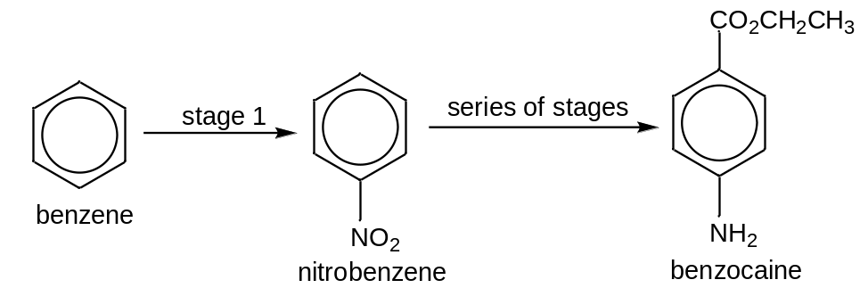
 |  | (i) | State and describe the mechanism involved in stage 1 of the above synthesis sequence.

 |  | (ii) | Benzocaine can be broken down to form 4-aminobenzoic acid.  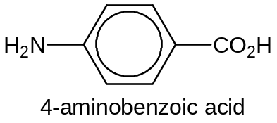  4-aminobenzoic acid reacts with both NaOH(aq) and CH₃COCl. Suggest the structures of the organic products formed in the boxes provided.  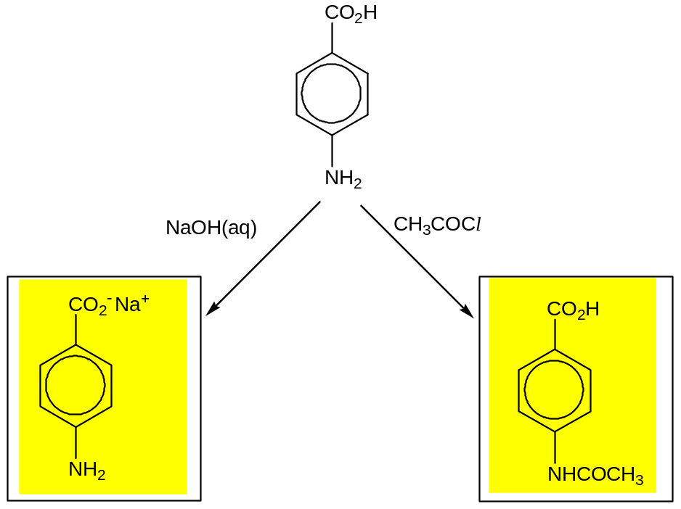
 |  |  |  | [5]

 | (c) | In the human body, there are more than 100,000 different kinds of proteins. These proteins are made up of amino acids. Examples of amino acids are shown below.  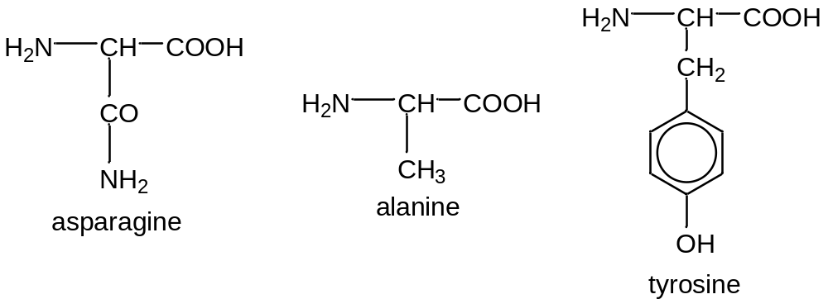
 |  | (i) | Alanine is able to exhibit stereoisomerism.  State the type of stereoisomerism which occurs in alanine and draw two structures which illustrate this isomerism.
 |  |  | Type of stereoisomerism: | ……………………………………………...
 |  |  | Structures:
 |  | (ii) | Draw the displayed formula of a dipeptide formed from one molecule of alanine and one molecule of asparagine, showing the ionic form in which it would exist at pH 2.

 |  | (iii) | Describe a simple chemical test to distinguish between alanine and tyrosine.
 |  |  | ………………….………………………………………………………………
 |  |  | …………….……………………………………………………………………
 |  |  | …………….……………………………………………………………………
 |  |  |  | [6]
 |  |  | [Total: 20]

5 | (a) | Jasmonic acid, methyl jasmonate and jasmone are volatile natural compounds extracted from jasmine flowers.
 |  | 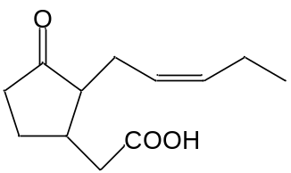jasmonic acid | 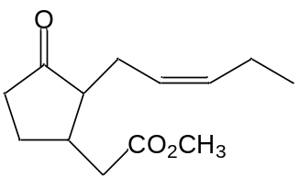methyl jasmonate | 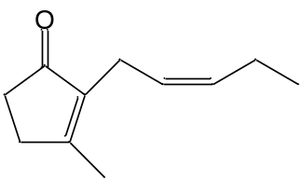jasmone
 |  | Describe, by means of simple chemical tests, how you would distinguish between the three compounds shown above.
 |  | …………………………………………………………………………………………
 |  | …………………………………………………………………………………………
 |  | …………………………………………………………………………………………
 |  | …………………………………………………………………………………………
 |  | …………………………………………………………………………………………
 |  | …………………………………………………………………………………………
 |  | …………………………………………………………………………………………
 |  | ………………………………………………………………………………………… |  |  | [4]
 | (b) | State the reagents and conditions for converting jasmonic acid to methyl jasmonate in the laboratory.
 |  | ………………………………………………………………………………………… |  |  | [1]
 | (c) | Jasmonic acid and methyl jasmonate function as volatile signaling molecules that are released when plants suffer injury.  State and explain which of the compounds you would expect to be more volatile.
 |  | …………………………………………………………………………………………
 |  | …………………………………………………………………………………………
 |  | …………………………………………………………………………………………
 |  | ………………………………………………………………………………………… |  |  | [2]
 |  | [Total: 7]

6 | The hydroxides of Group I metals (LiOH, NaOH, KOH, RbOH, CsOH) are highly corrosive white solids which rapidly absorb water vapour on exposure to the atmosphere.  All these solids dissolve exothermically in water.  The enthalpy change of solution, ΔH_{soln}, is the energy change associated with the following reaction. M represents the Group I metal.  MOH(s) + (aq) → M⁺(aq) + OH⁻(aq)
 | (a) | The enthalpy change of solution, ΔH_{soln}, for any Group I hydroxide can be measured experimentally in the laboratory.  In experiments to compare ΔH_{soln} for LiOH, NaOH, KOH, RbOH, CsOH, state:
 |  | the independent variable |  |  | ……………………….……………………………….
 |  | …………………………………………………………..……………………………..
 |  | the dependent variable |  | …………………………………….…………………….
 |  | …………………………………………………………..……………………………..
 |  | the other variable to be controlled |  |  |  | ……………………………………………...
 |  | …………………………………………………………..……………………………..
 |  |  |  |  |  |  | [2]
 | (b) | Draw a labelled diagram to show the apparatus you would use to obtain data from which ΔH_{soln} could be determined.
 |  | From the information given in this question and the apparatus you plan to use, identify two possible sources of error in the experiment and state how you would minimise the effect of each.
 |  | Error 1 | ………………………………………………………...……………………
 |  | …………………………………………………………..……………………………..
 |  | …………………………………………………………..……………………………..
 |  | Error 2 | ………………………………………………………...……………………
 |  | …………………………………………………………..……………………………..
 |  | …………………………………………………………..……………………………..
 |  |  |  |  |  |  | [3]
 | (c) | Identify a health and safety risk in the experiment and explain how you would minimise it when carrying out the experiment.
 |  | ……………………………………………………...………………………………….
 |  | ………………………………………………………………………………………… |  |  |  |  | [1]
 | (d) | Describe the procedure you would carry out to find the enthalpy change of solution, ΔH_{soln}, for one of the Group I hydroxides.  Your plan should give a step-by-step description of the method, including  - how you would measure the independent variable,  - how you would measure the dependent variable,  - appropriate masses and volumes of reagents.  The following data may be of use in planning the detail of your experiment.
  A_{r}: Li, 6.9; Na, 23.0; K, 39.1; Rb, 85.5; Cs,
  133.0; O, 16.0; H, 1.0
  4.3 J are required to raise the temperature of 1.0 cm³ of any solution by 1 °C.
 |  | ……..…………………………………………………………………………………..
 |  | ……..…………………………………………………………………………………..
 |  | ……..…………………………………………………………………………………..
 |  | ……..…………………………………………………………………………………..
 |  | ……..…………………………………………………………………………………..
 |  | ……..…………………………………………………………………………………..
 |  | ……..…………………………………………………………………………………..
 |  | ……..…………………………………………………………………………………..
 |  | ……..…………………………………………………………………………………..
 |  | ……..…………………………………………………………………………………..
 |  | ……..…………………………………………………………………………………..
 |  | ……..…………………………………………………………………………………..
 |  | ……..…………………………………………………………………………………..
 |  | ……..…………………………………………………………………………………..
 |  | ……..…………………………………………………………………………………..
 |  | ……..…………………………………………………………………………………..
 |  | ……..…………………………………………………………………………………..
 |  | ……..…………………………………………………………………………………..
 |  | ……..…………………………………………………………………………………..
 |  | ……..…………………………………………………………………………………..
 |  | ……..…………………………………………………………………………………..
 |  | ……..…………………………………………………………………………………..
 |  | ……..…………………………………………………………………………………..
 |  | ……..…………………………………………………………………………………..
 |  | ……..………………………………………………………………………………….. |  |  |  |  | [4]
 | (e) | The procedure is repeated for each of the Group I hydroxides.  Show how you would tabulate the results for all the experiments.
 |  |  |  |  |  |  | [1]
 | (f) | Show how you would use the results of one experiment to calculate the enthalpy change of solution, ΔH_{soln}, for the reaction.
 |  |  |  |  |  |  | [1]
 |  | [Total: 12]

END OF PAPER

